NIP Project — Submission Template
Pega Platform project · This document is your complete submission
Read this before you start:
1. Fill in Section 1 completely. The Pega application name must follow the format NIP-[Project]-[YourName].
2. Create a new Operator in Pega with your full name and log in as that operator before taking any screenshot.
3. When you create your test case, enter YOUR FULL NAME in the Issue Description (Vehicle) or Movie Name (Movie) field.
4. Complete only the section for your chosen project. Delete the other project section.
5. Paste one screenshot per user story (10 total). Follow the screenshot rules in your selected project section.
6. Answer every question in Sections 3 and 4 in your own words.
7. Save the file using this format: ProjectName_FirstName_LastName.docx. Use VehicleService or MovieTicket as the ProjectName. Examples: VehicleService_Ravi_Kumar.docx or MovieTicket_Ravi_Kumar.docx.

Section 1 — Your Details
Full Name | BOGA BHARATH KUMAR
Email ID (registered on NIP) | bogabharath1607@gmail.com
Phone Number | 8143756963
College Name | Guru Nanak Institute of Technology (GNIT)
Course (e.g. IT, CS) | Computer Science and Engineering
State | Telanganna
Project Chosen (Vehicle Service OR Movie Ticket Booking) | Movie Ticket Booking
Pega Application Name (e.g. NIP-VehicleService-YourName) | NIP-MovieTicket-BharathKumar
Case Type Name (exact) | Movie Ticket Request
Pega Instance URL | https://witifuau.pegaacademy.net/prweb/app/ticketing-and-booking/CtYds566Y7g0wqmzQXJaidwV3WuwKfQA*/!STANDARD?pzPostData=-1363497171
Operator Name (created in Pega with your full name) | BOGA BHARATH KUMAR

Section 2B — Movie Ticket Booking Management Application
Complete this section only if you selected this project. Delete the other project section before submitting.

Screenshot rules — IMPORTANT before you start:
1. Name your Pega application as: NIP-VehicleService-YourName OR NIP-MovieTicket-YourName
2. Create a new Operator in Pega with your full name (Security → Operators) and log in as that operator.
3. When you create your test case, enter YOUR FULL NAME in the Issue Description (Vehicle) or Movie Name (Movie) field.
4. The logged-in operator name must be visible in every screenshot wherever the Pega interface displays it.
5. The student's full name must be visible in all running-case screenshots.
6. Configuration screenshots must clearly show the relevant application or rule name.
Screenshots that do not show these will not be accepted.

US-001 — Submit Movie Ticket Request
What is expected:
Case created, customer submits Movie Name, Show Date, Show Time, Number of Tickets. Validation applied.
Screenshot — paste your screenshot below this line:
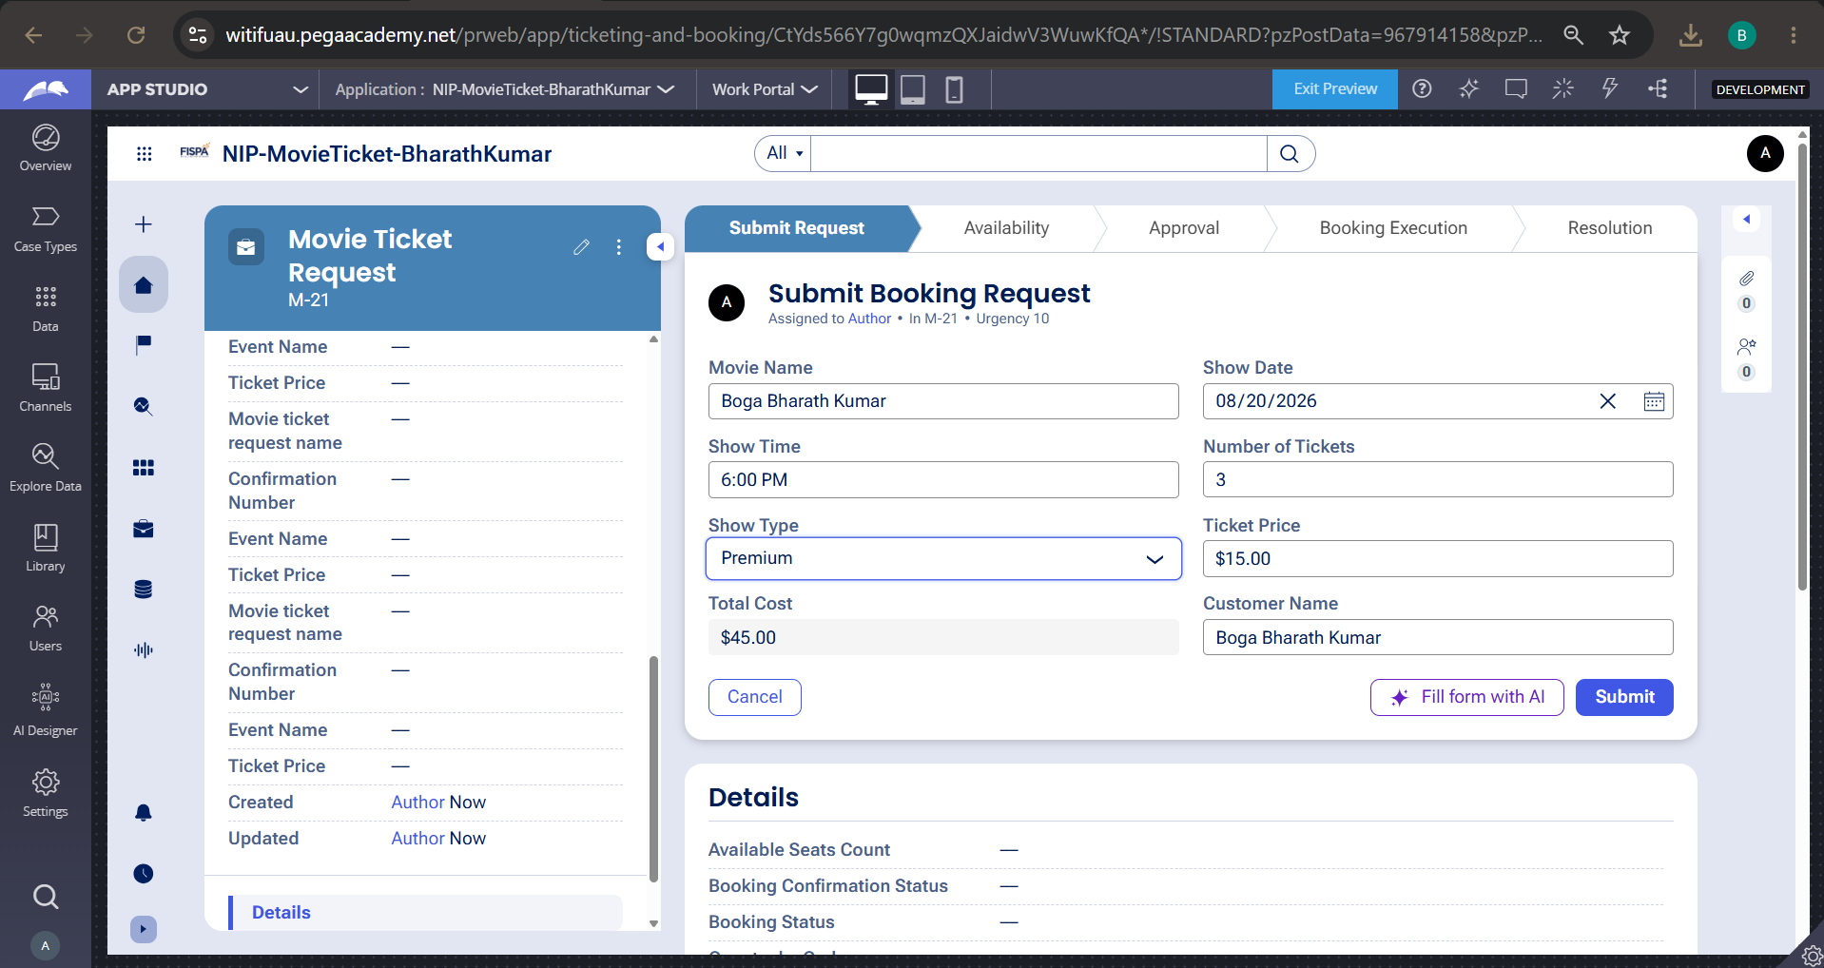

What I built for this (1–2 lines in your own words):
I created the initial submission stage where users enter their movie booking details, which then kicks off the case flow for CineWave Entertainment.

US-002 — Check Show Availability
What is expected:
Availability stage. Seat Availability Status and Available Seats Count captured. Booking proceeds only if available.
Screenshot — paste your screenshot below this line:
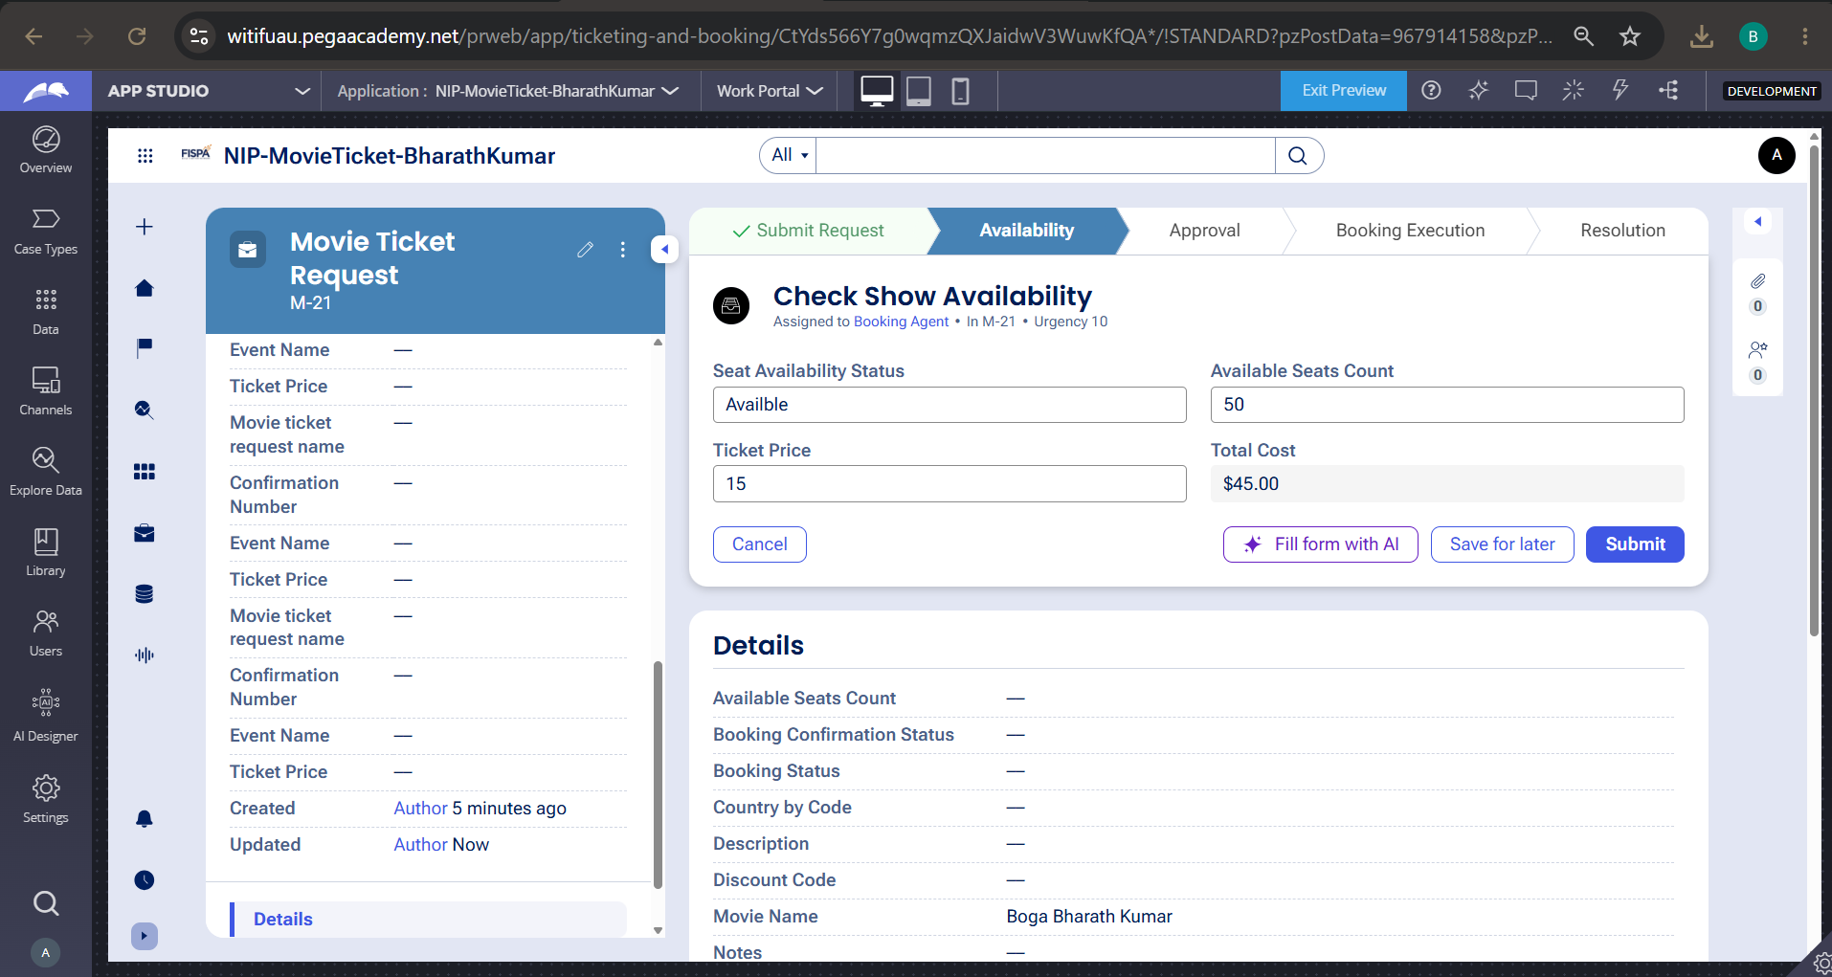

What I built for this (1–2 lines in your own words):
I configured a step to verify show availability, capturing the available seat count and status to make sure users only book when tickets are available.

US-003 — Calculate Booking Cost
What is expected:
Total Cost calculated automatically from Ticket Price and Number of Tickets using a business rule.
Screenshot — paste your screenshot below this line:


What I built for this (1–2 lines in your own words):
I implemented automated pricing calculation so that whenever the user enters the number of tickets, the system derives the total cost instantly.

US-004 — Confirm Booking Request
What is expected:
Approval stage assigned to Customer. Booking Status captured. Flow branches on confirm/cancel.
Screenshot — paste your screenshot below this line:
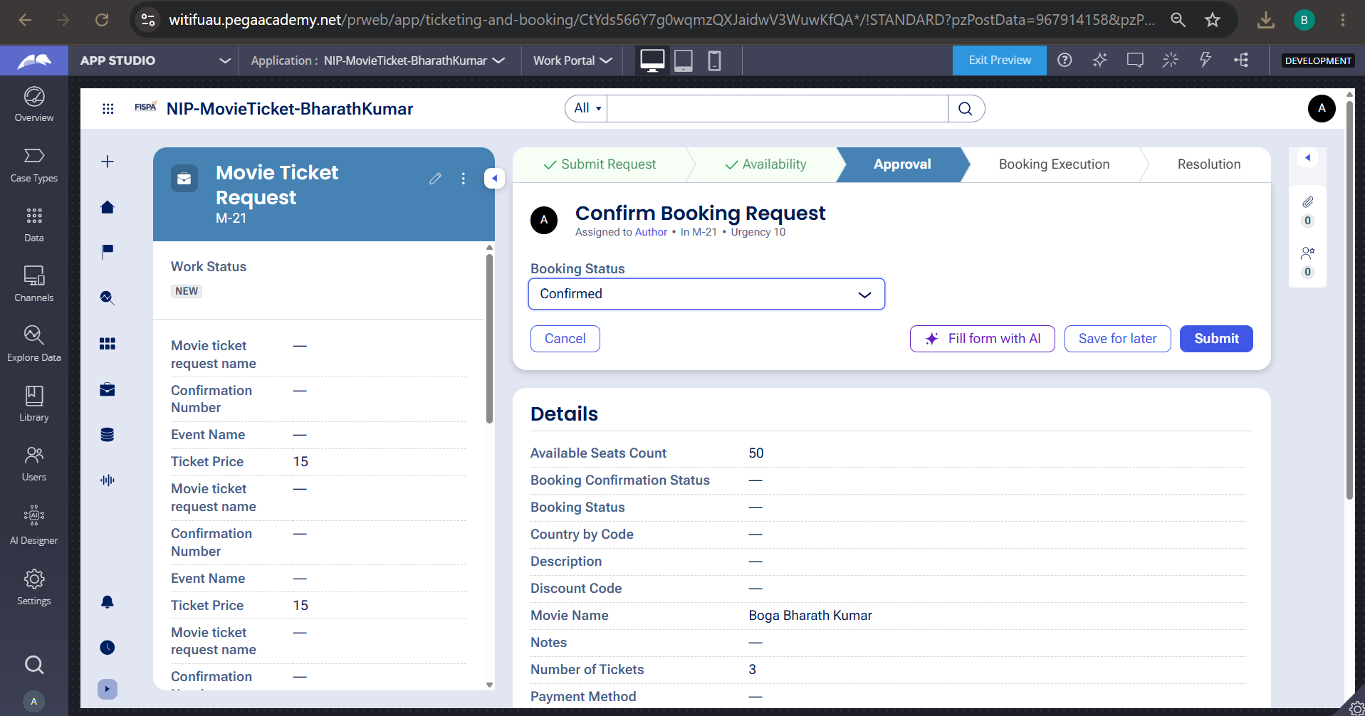

What I built for this (1–2 lines in your own words):
I built an Approval stage where the booking details are presented for review and the booking status is set to Confirmed to approve the reservation.

US-005 — Maintain Movie and Show Data
What is expected:
Reusable Movie and Show data objects created with Movie Name, Genre, Show Date, Show Time, Seat Capacity — linked to case.
Screenshot — paste your screenshot below this line:
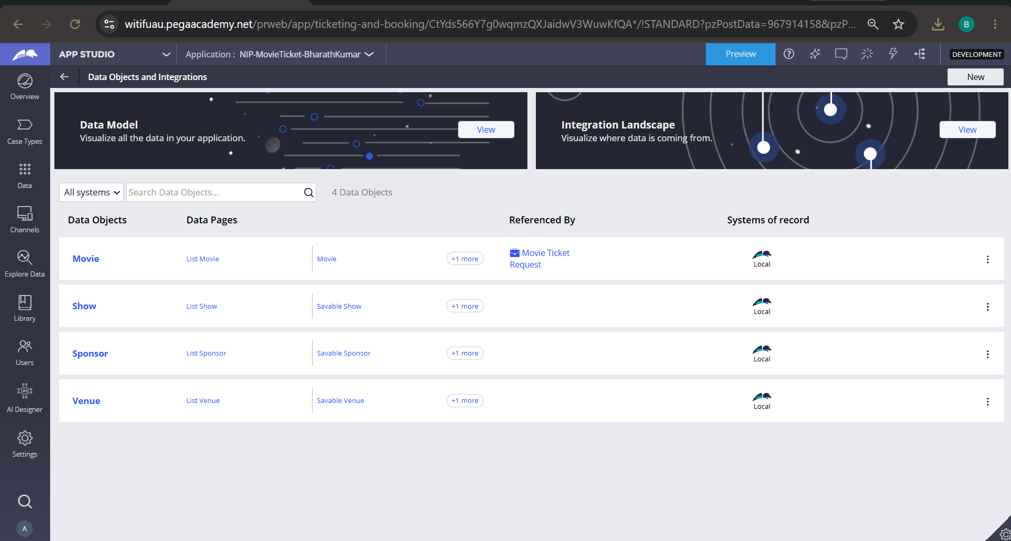

What I built for this (1–2 lines in your own words):
I configured reusable Movie and Show data objects to maintain theater catalog records and link show information directly into the booking lifecycle.

US-006 — Review Booking Details
What is expected:
Confirmation screen shows Movie Name, Show Timing, Number of Tickets and Total Cost clearly.
Screenshot — paste your screenshot below this line:
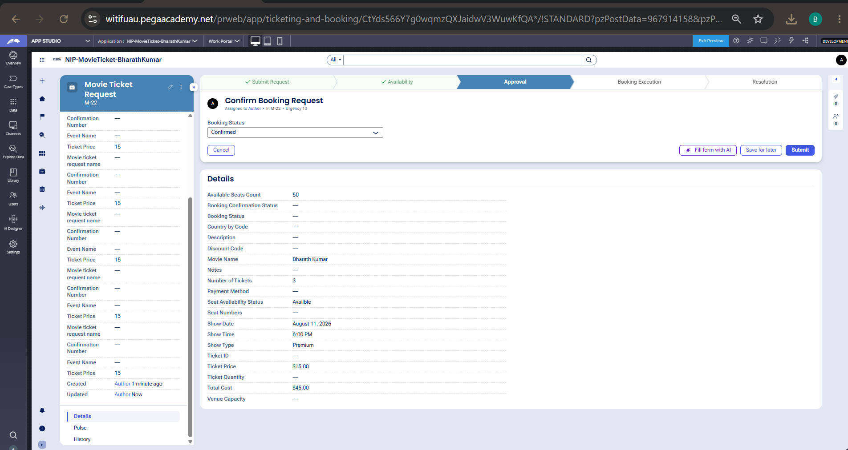

What I built for this (1–2 lines in your own words):
I configured a review screen that aggregates customer details, show schedule, and pricing so the booking can be thoroughly verified before processing.

US-007 — Process Ticket Booking
What is expected:
Booking Execution stage. Seat Numbers, Ticket ID and Booking Confirmation Status maintained.
Screenshot — paste your screenshot below this line:
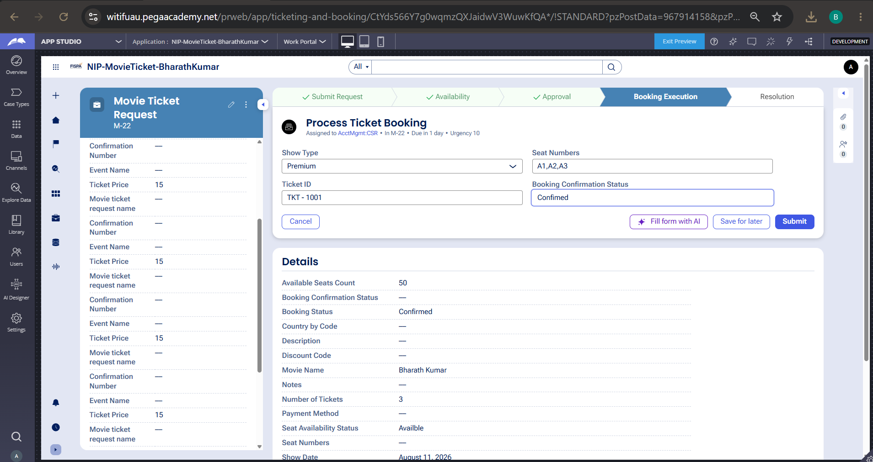

What I built for this (1–2 lines in your own words):
I configured an automated processing step that assigns seat numbers and updates the booking record once the request is approved.

US-008 — Notify Booking Confirmation
What is expected:
Correspondence rule triggered on case resolution. Email includes movie, show, seat and cost details.
Screenshot — paste your screenshot below this line:
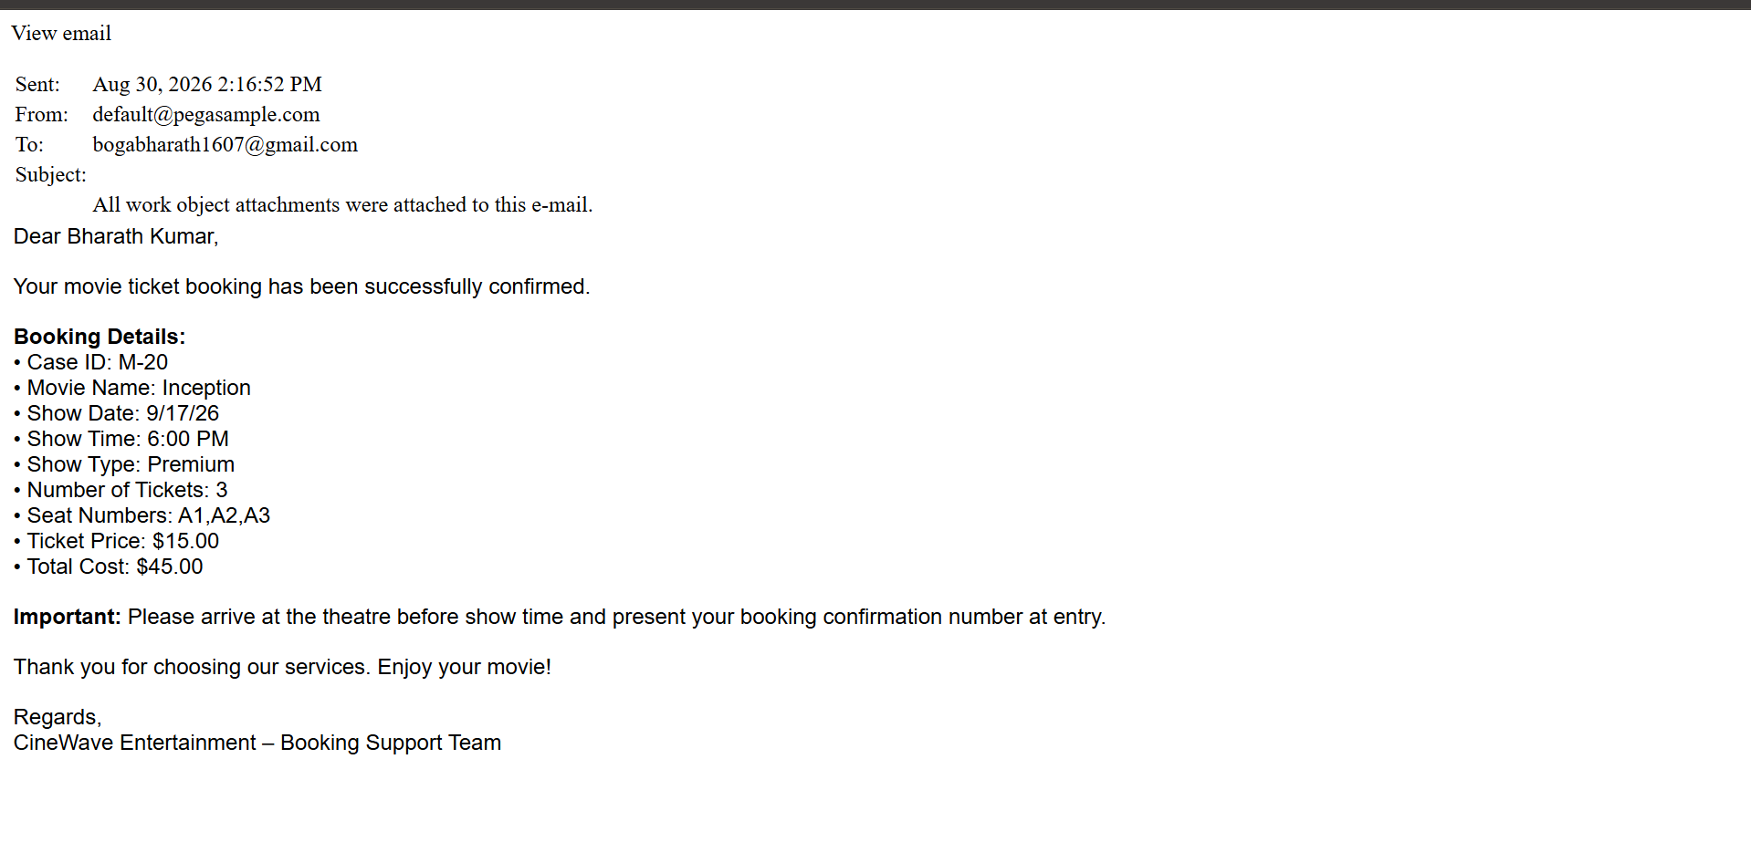

What I built for this (1–2 lines in your own words):
I set up an automated correspondence step in the Resolution stage that dynamically maps customer and booking properties into a formatted confirmation email upon case completion.

US-009 — Define Booking SLA
What is expected:
SLA configured on the case type. Goal: 1 day. Deadline: 2 days. Priority increases on breach.
Screenshot — paste your screenshot below this line:
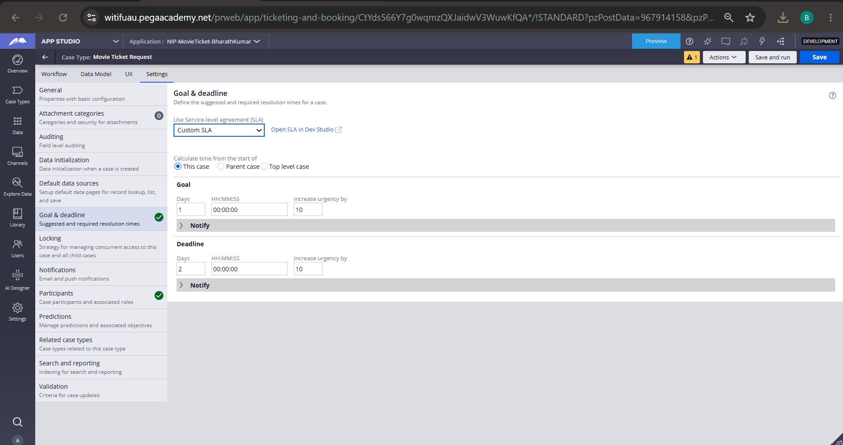

What I built for this (1–2 lines in your own words):
I configured a custom Goal and Deadline SLA at the case level to enforce timely booking resolution and escalate case urgency automatically.

US-010 — Route by Show Type
What is expected:
Routing rule or Decision Table routes to PremiumShowQueue or StandardShowQueue based on Show Type property.
Screenshot — paste your screenshot below this line:
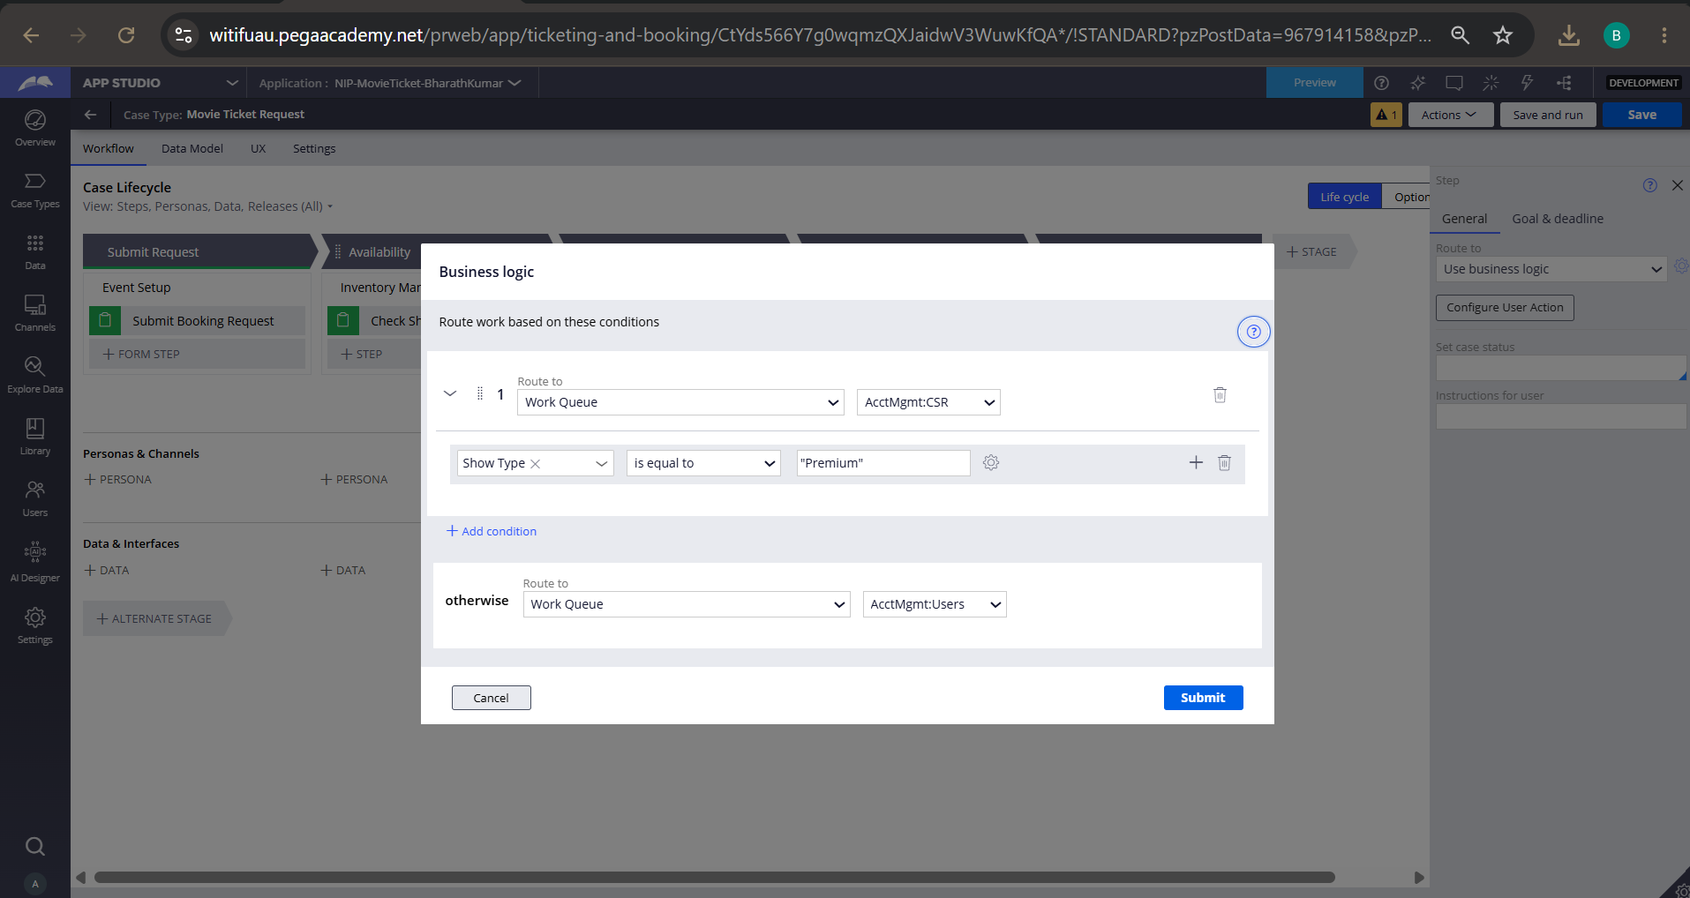

What I built for this (1–2 lines in your own words):
I implemented conditional work queue routing based on Show Type so that Premium requests are automatically assigned to dedicated queues.

Section 3 — About Your Application
These answers are checked against your screenshots. Write exactly what is in your application.

Q1. List your stages in the order they appear in your case lifecycle.
Stage names in order, separated by commas.
Submit Request, Availability, Approval, Booking Execution, Resolution

Q2. Name the data object(s) you created and the properties inside them.
Data object name and its properties.
- Data Object Name: Movie
- Properties: Movie Name, Movie ID, Genre, Duration, Language, Description

- Data Object Name: Show
- Properties: Show ID, Movie Name, Show Date, Show Time, Show Type, Venue Capacity, Available Seats Count, Ticket Price

Q3. What is the exact name and type of the rule you used to calculate Total Cost?
Provide:
• Rule Name
• Rule Type
• Properties used in the calculation
• Formula used
Rule Name: TotalCost (or Total Cost)
Rule Type: Calculated Field (Expression / Declare Expression)
Properties used in the calculation: TicketPrice_1 (or TicketPrice), NumberOfTickets
Formula used: .TicketPrice_1 * .NumberOfTickets (or .TicketPrice * .NumberOfTickets)

Section 4 — Your Understanding
Short, honest and specific answers score well.

Q4. What did Blueprint generate for you, and what did you add or change yourself afterwards?
Be specific about what was already there and what you built or modified on top.
Blueprint generated the initial high-level case lifecycle stages (Submit Request, Availability, Approval, Booking Execution, Resolution), basic persona suggestions, and primary data object structures for Movie and Show details.
After importing the blueprint, I configured the custom data model, added specific property fields (such as Customer Name, Seat Numbers, and Show Type), built the dynamic Total Cost calculation logic (.TicketPrice * .NumberOfTickets), implemented conditional business logic routing based on Show Type, and customized the automated confirmation email template in the Resolution stage.

Q5. Was there anything Blueprint created that you had to correct or configure further? Describe one example.
A real example from your own work.
Blueprint created the field structure for Total Cost and the notification step, but it did not include the automated calculation formula or dynamic property bindings for email correspondence.

I had to configure Total Cost as a calculated field using an expression rule (.TicketPrice_1 * .NumberOfTickets) so it updates automatically. I also updated the correspondence template in the "Notify Booking Confirmation" step with dynamic property references (<<.CustomerName>>, <<.pyID>>, <<.TotalCost>>) to ensure the generated email resolves real runtime booking data instead of static placeholder text.

Q6. Explain your case flow from creation to resolution, in order.
What happens first, who does what, when the case closes.
Submit Request: The customer/user initiates the case and fills in booking details, including movie name, show date, show time, show type, and ticket count. Total cost is derived automatically.
Availability: The Booking Agent checks theater capacity, confirms seat availability status, and verifies available seat counts.
Approval: The submitted booking summary and pricing details are reviewed, and the booking confirmation status is updated.
Booking Execution: The case routes dynamically based on Show Type (directing Premium bookings to the CSR queue and Standard bookings to the general queue) where seat numbers are allocated.
Resolution: The system automatically sends a personalized confirmation email containing the full booking breakdown to the customer and resolves the case to Completed status.

Q7. Pick two design choices you made in your application and explain why you made them.
For each design choice, provide:
• What you implemented
• Why you chose that approach
• What benefit it provides to the application
What I implemented: Automated Calculated Field for TotalCost using an expression rule (.TicketPrice_1 * .NumberOfTickets).
Why I chose that approach: Rather than relying on manual calculation or custom backend scripts, I utilized Pega's declarative calculation model directly on the case property.
What benefit it provides to the application: It prevents human calculation errors, updates dynamically the moment the ticket quantity changes, and keeps the field read-only to avoid unauthorized alterations.

Q8. What was the hardest part, and how exactly did you fix it?
Specific and honest. A real challenge scores much better than a generic answer.
The hardest part was ensuring that the automated correspondence email dynamically resolved all runtime case properties (such as .CustomerName, .pyID, and .TotalCost) without displaying literal tag placeholders or blank lines in the final output.
I resolved this by inspecting the property references within the data model, properly configuring the rich text template inside the "Notify Booking Confirmation" step with exact property tag bindings (<<.CustomerName>>, <<.TotalCost>>), and thoroughly testing case runs end-to-end to verify that all values resolved cleanly on the generated email preview.

Q9. If the approval step was only needed when Total Cost is above a certain amount, what would you change in your application?
Explain what you would change and where. You do not need to build this.
I would add a skip/start condition directly to the Approval stage (or step) in the case lifecycle:
- Where: In App Studio / Dev Studio under Movie Ticket Request $\rightarrow$ Workflow $\rightarrow$ select the Approval stage/step contextual properties panel.
- What to change: Set the stage/step execution rule to "Custom condition" with the logic:
Total Cost is greater than [Threshold Amount] (e.g., .TotalCost > 100).
- Result: If the total cost is below or equal to the threshold, the case skips the approval stage entirely and moves straight from Availability to Booking Execution; otherwise, it routes for mandatory managerial review.

Q10. List three exact rule names from your application that you personally created or modified.
Include the rule name and rule type for each one (for example: CalculateTotalCost - Declare Expression).
TotalCost – Declare Expression (Calculated Field)
Notify Booking Confirmation – Correspondence (Send Email Step)
Submit Booking Request – Section (User Action / View)

Q11. List all personas used in your application.
List the persona names exactly as they appear in your application.
Customer
Booking Agent
Customer Service Representative

Q12. List all work queues used in your application and explain when each one is used.
For each work queue, provide its exact name and the condition or type of work routed to it.
AcctMgmt:CSR
- When used: Used during the Booking Execution stage when a customer selects a Premium show type (Show Type = "Premium"), routing the case to dedicated customer service representatives for prioritized seat processing.
AcctMgmt:Users
- When used: Used as the fallback default queue during Booking Execution for all standard and general show bookings (Show Type is not Premium) to be processed by standard operations staff.

